Hybrid Automatic Speech Recognition Utilizing Cross-Encoder Embedding Fusion

Mohaideen Abdul Kadhar K
Professor
Department of AI & Data Science Sri Eshwar College of Engineering Coimbatore, India mohaideen9683@gmail.com

Vignesh Pandiya G
Department of Artificial Intelligence and Data Science
Sri Eshwar College of Engineering Coimbatore, India
vigneshpandiyan.g2022ai-ds@sece.ac.in

Arun Kumar R
Department of Artificial Intelligence and Data Science
Sri Eshwar College of Engineering Coimbatore, India arunkumar.r2022ai-ds@sece.ac.in

Harrini Shree M
Department of Artificial Intelligence and Data Science
Sri Eshwar College of Engineering Coimbatore, India harrinishree.m2022ai-ds@sece.ac.in

Abstract—Automatic speech recognition (ASR) systems based on transformers have significantly increased the accuracy of the transcription in a variety of linguistic and acoustic environments. However, open-source applications like Whisper [1] degrade in performance when faced with spontaneous speech, noisy speech, or speech domain. In its turn, proprietary services, such as Deepgram [14][15], provide accurate timestamps and confidence scores, which can be attributed to their more robust acoustic modeling systems.
This paper presents a hybrid ASR system, known as CEEF (Cross-Encoder Embedding Fusion), a system combining the linguistic generalization properties of Whisper and the acoustic strength of Deepgram. CEEF has two main modules, including
(1) a confidence-weighted logits steering mechanism that controls the token probabilities during decoding; and (2) a temporally biased cross-encoder fusion module that aligns Whisper-encoded representations with Deepgram embeddings using Gaussian at- tention. Experimental analyses reveal that CEEF has lower word error rates, greater stability of decoding, and less latency than Whisper alone, without sacrificing computational tractability by using Low-Rank Adaptation (LoRA) [4]. The results suggest that hybrid ASR designs have the potential to outperform monolithic and ensemble designs, and can additionally encourage scalable, interpretable, and model-agnostic speech processing.
Index Terms—Automatic Speech Recognition, Whisper, Deep- gram, Cross-Attention, Logit Steering, LoRA, Multistream Fu- sion, Hybrid ASR

- Introduction
Natural, real-time communication across languages and en- vironments is now possible thanks to the development of Au- tomatic Speech Recognition (ASR), which has revolutionized human-computer interaction. Large-scale transformer-based models like Whisper [1] have emerged, and ASR has moved from modular pipelines to unified end-to-end architectures that can simultaneously learn linguistic and acoustic patterns. Notwithstanding these developments, problems still exist in domain-specific speech, dynamic acoustics, and low-resource languages [16], [17].
High reliability is demonstrated by commercial speech APIs such as Deepgram [14] and Google Speech, which pro- vide timestamped word alignments, phoneme-level confidence scores, and continuous acoustic calibration. Nevertheless, in- terpretability and adaptability are restricted by these closed models. On the other hand, open-source systems are superior in terms of customization and transparency, but they frequently lack the real-time acoustic refinement found in enterprise- grade services.
This work uses the Cross-Encoder Embedding Fusion (CEEF) framework to bridge the gap between open and closed ASR systems. Whisper’s decoding process incorporates Deep- gram’s acoustic representations as a secondary knowledge stream. The CEEF model consists of two primary fusion strategies: (1) a time-biased cross-encoder attention mecha- nism that uses Gaussian temporal alignment to synchronize encoder states across the two systems, and (2) a logit steering module that modifies token probabilities using Deepgram’s confidence-weighted priors.
The following are the main reasons for the study:

- To investigate the performance improvements that can be obtained by combining heterogeneous ASR architectures at the representation level as opposed to output level ensembling.
- In order to determine the feasibility of training a hybrid architecture that is computationally efficient, LoRA [4] to create a pipeline for interpretable ASR that combines linguistic context awareness, acoustic robustness, and timestamp accuracy.
This paper is structured as follows. Section II reviews fun- damental work on end-to-end automatic speech recognition, contextual biasing, and fusion methods. Section III outlines the proposed methodology, incorporating mathematical formu-

lations for the steering and cross-fusion components of CEEF. Section IV outlines the experimental setup and evaluation metrics, with results and analysis presented in Section V. Section VI presents implications and future extensions related to multilingual and streaming applications.
- Related Work
- End-to-End Speech Recognition
Conventional automatic speech recognition (ASR) systems depended on separate acoustic, pronunciation, and language models [11]. End-to-end approaches such as Listen, Attend and Spell (LAS) [3] and Transformer-based seq2seq architec- tures [2] replaced these components with unified attention- based learning. Massive transformer ASR systems such as Whisper [1] and wav2vec 2.0 are able to use massive datasets to provide high levels of robustness and cross-domain gener- alization. Nevertheless, these models can be inadequate in real time adaptation and integration of external bias.
- Contextual and External Biasing
Contextual biasing methods improve accuracy of transcrip- tion of specialized vocabularies or entity-rich language by introducing priors at the time of decoding, such as shallow and deep methods, respectively, in practice. Such techniques as Shallow Fusion [5] incorporate external language model probabilities, and Deep Contextual ASR [6] incorporates bias phrases into encoder - decoder attention. Subsequent inno- vations [7] examined neural contextualization to personalize on devices. However, they all mainly work on the linguistic level, but CEEF also presents the acoustic-level biasing by embedding fusion in models.
- Hybrid and Multistream ASR Fusion
A combination of several input streams has been found to be more robust particularly in the presence of noise. Audio- visual fusion models include models that use synchronized audio and video attention to solve audio signal ambiguity [8], [9]. Equally, ensemble-based aggregation of decoders has been tested in hybrid ASR frameworks which also experimented with multiple decoders of varying types and sizes [10]. CEEF is unique in that it allows incorporating two encoders in the ASR directly on the latent level, and with time-sensitive cross- attention, instead of post-decoding fusion of the scores.
- Parameter-Efficient Adaptation
The full fine-tuning of the ASR transformers requires a lot of memory and computer resources. The Low-Rank Adapta- tion (LoRA) model [4] overcomes this obstacle by training small matrices of rank-decomposition in attention projections. Other related techniques like adapter tuning and prefix-tuning have been shown to be effective in quick domain change. LoRA also makes it possible to scalably integrate Deepgram embeddings into Whisper by re-training the full backbone model, but this is not the case in CEEF.
- Streaming and Real-Time ASR Systems
Real-time ASR is a low latency but high quality transcrip- tion. Streaming architectures like RNN-T [12] and Conformer- based systems [13] have optimized partial hypotheses for continuous decoding. Deepgram’s API [14], [15] extends this capability to provide continuous timestamped confidences, offering an ideal substrate for CEEF’s real-time hint-guided decoding.
- Research Gap
Although hybridization of ASR systems has been previ- ously attempted through ensemble voting or shallow score fu- sion [5], little work has explored embedding-level integration between two independent ASR models. CEEF fills this gap by coupling a proprietary acoustic encoder (Deepgram) with an open-source transformer (Whisper), using cross-attention mechanisms that respect temporal alignment and uncertainty weighting.
- Proposed Methodology
The proposed Cross-Encoder Embedding Fusion (CEEF) framework establishes a hybrid architecture that unifies the linguistic generalization ability of Whisper with the acous- tic reliability of Deepgram through two complementary fu- sion strategies: (1) Confidence-Weighted Logit Steering, and
(2) Time-Biased Cross-Encoder Fusion. The design enables representation-level information exchange while maintaining low-latency performance and scalability.
- System Overview
CEEF operates as a two-stream ASR pipeline (Fig. 1). The first stream comprises Whisper’s transformer encoder–decoder, which extracts latent acoustic-linguistic representations from input speech and predicts text sequences. The second stream consists of Deepgram’s live transcription engine, which pro- duces phoneme-level embeddings and word-level hints, each annotated with start and end timestamps, confidence scores, and stability measures.
These Deepgram hints are continuously ingested into the CEEF engine and processed in real time. The Whisper encoder consumes the original waveform while the decoder dynami- cally adjusts its token probability distribution based on the fused information from the Deepgram embeddings.
- Notation and Data Flow
Let an input audio signal be represented as x R^{T} sampled at 16 kHz. Whisper encodes x into a sequence of hidden states E = [e₁, e₂, . . . , e_{L}] R^{L×d}, where L denotes the number of encoder frames and d the embedding dimension. Deepgram provides a structured hint set = (w_{i}, s_{i}, e_{i}, c_{i}) ^{K} , where each tuple contains the recognized word w_{i}, start and end timestamps (s_{i}, e_{i}), and a confidence score c_{i} [0, 1].
∈
∈
i=1
∈
H { }
The CEEF architecture utilizes to generate both (i) token priors that modify Whisper’s decoding logits and (ii) em- bedding vectors that interact with Whisper’s encoder features through cross-attention.
H

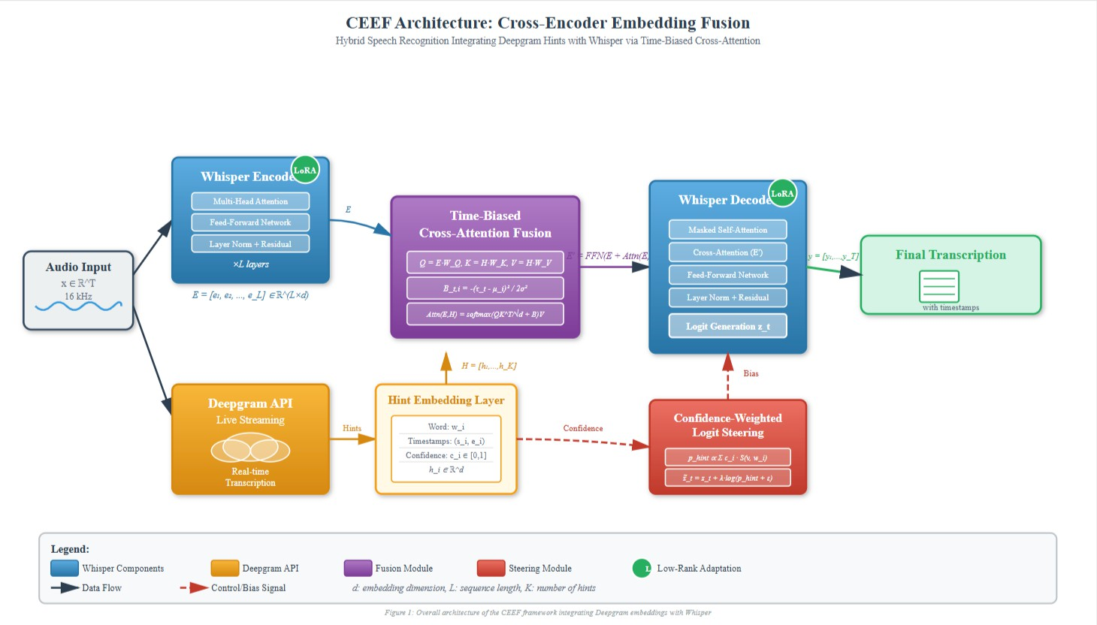
E. Time-Biased Cross-Encoder Fusion
CEEF introduces a time-biased cross-attention layer to inte- grate Deepgram hints with Whisper’s internal representations. For the encoder state e_{t} at time τ_{t} = t ∆t and the Deepgram embedding h_{i} centered at µ_{i} = (s_{i} + e_{i})/2, attention is calculated as follows:
·
Q = EW_{Q}, K = HW_{K}, V = HW_{V} , (5)
(τ_{t} − µ_{i})²
B_{t,i} = − 2σ2 , (6)

Attn(E, H) = softmax
QK⊤
√d + B
V. (7)

Fig. 1. Overall architecture of the CEEF framework integrating Deepgram embeddings with Whisper through logit steering and time-biased cross- encoder fusion.

- Confidence-Weighted Logit Steering
A Gaussian prior matrix B is introduced to align the timing of Whisper’s frame-level features with Deepgram’s word- level anchors, enhancing the influence of acoustically aligned segments. The resulting fusion vector is iteratively adjusted as follows:

During decoding, Whisper produces a logit vector z_{t} R^{V} over the vocabulary set at each timestep t. CEEF introduces a steering prior p_{hint} ∆^{V} ⁻¹ derived from Deepgram’s word confidences to adjust these logits as follows:
∈
V
∈
K
Σ
p_{hint}(v) ∝ c_{i} · S(v, w_{i}), (1)
i=1

where S(v, w_{i}) denotes a token-to-word similarity function (e.g., prefix match or subword overlap). The logits are then modified using a weighted additive correction:
z˜_{t} = z_{t} + λ · log(p_{hint} + ϵ), (2)
where λ is the steering strength and ϵ prevents numerical instability. The probability distribution is then normalized using the softmax function:
P (y_{t}|x, H) = softmax(z˜_{t}). (3)
This aspect gives a bias in decoding to words that have high external confidence and still has Whisper to intrinsically reason in context.

- Deepgram Hint Embedding Layer
All the Deepgram hints are transformed into a vector representation of the Deepgram hints, denoted by, the lexical, temporal, and confidence-based features, as, h_{i} ∈ R^{d}
h_{i} = W[Emb(w_{i}) ϕ_{time}(s_{i}, e_{i}) c_{i}], (4) where Emb(w_{i}) represents the learned token embedding, and
ϕ_{time}(s_{i}, e_{i}) encompasses the normalized duration and mid-
time of the spoken word. The matrix of hint embeddings H = [h₁, . . . , h_{K}] serves as the secondary input stream for the fusion module.
E′ = FFN (E + Attn(E, H)) , (8)
where FFN denotes a feed-forward sublayer with residual connections.
- Training Objective and Optimization
The model is optimized using a combination of cross- entropy and agreement losses:
L = L_{CE} + αL_{agree} + βL_{time}, (9) where _{CE} denotes the token-level cross-entropy loss, _{agree}
L L
aligns model predictions with Deepgram hint priors, and _{time} regularizes temporal consistency between Whisper’s predicted timestamps and external alignments. The coefficients α and β balance these terms empirically.
L
- Parameter-Efficient Tuning with LoRA
Fine-tuning large transformer-based ASR models is resource-intensive. CEEF employs Low-Rank Adaptation (LoRA) [4] to introduce lightweight trainable matrices within Whisper’s attention layers. For any projection weight W R^{d}out×din , the update is represented as:
∈
W′ = W + BA, (10)
where A R^{r×d}in and B R^{d}out×r, with r d_{in}, d_{out}. This strategy significantly reduces training cost while preserving Whisper’s pretrained generalization.
∈ ∈ ≪
- Model Workflow Summary
As summarized in Fig. 2, the complete workflow begins with simultaneous streaming of the input waveform into Whisper and Deepgram. Deepgram’s hint embeddings and confidences are fused with Whisper’s encoder representations through the time-biased cross-attention block, while the de- coder integrates the steering prior for token prediction. Both batch and streaming inference modes are supported by the final system.

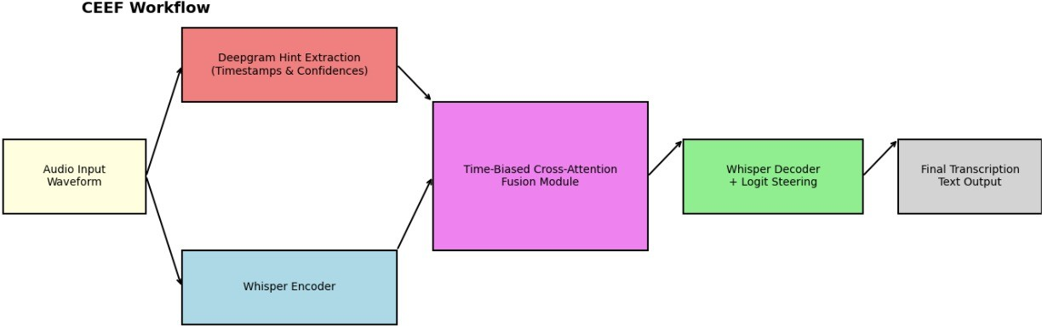

Fig. 2. Detailed workflow of the CEEF pipeline.

- Experimental Setup
The experimental setting, datasets, preprocessing tech- niques, model setup, and evaluation metrics utilized to gauge the efficacy of the suggested CEEF framework are all pre- sented in this section.
- Datasets
To guarantee generalization and task relevance, experiments were carried out using a mix of publicly accessible and domain-specific datasets:
  - LibriSpeech Test-Clean and Test-Other: a standard English speech corpus with roughly 100 hours of tran- scribed audio that was taken from audiobooks. It acts as a standard for hygienic and reasonably noisy surroundings.
  - Mozilla Common Voice (Indian English Subset) is a crowdsourced, multilingual dataset that captures record- ing variability and accent. This dataset aids in assessing CEEF in a variety of speaker scenarios.
  - About 25 hours of speech data, including product in- quiries, background noise, and overlapping speech seg- ments, were gathered from call centers and conversa- tional scenarios to create the In-House Domain-Specific Dataset. The real-world adaptability and streaming sta- bility of CEEF were verified using this dataset.
- Data Preprocessing
To maintain consistency between datasets, every audio file was converted to mono at 16 kHz and normalized to a loudness of 23 dBFS.. Silence segments shorter than 500 ms were retained to preserve natural pauses, while longer silences were trimmed. For training, each audio file was divided into overlapping chunks of 10 s duration with a stride of 2.5 s, following the best practices of speech transformer training. Using Whisper’s multilingual byte-pair encoding (BPE) tok- enizer, the accompanying text transcripts were tokenized.
—
- Model Configuration
The CEEF system integrates the Whisper-base model [1] (74M parameters) with Deepgram’s real-time streaming tran- scription API [14]. Two primary configurations were tested:
  - CEEF-S (Steering Only): Whisper model with Deep- gram confidence-guided logit steering enabled, without embedding fusion.
  - CEEF-X (Cross-Fusion Enabled): Whisper model aug- mented with time-biased cross-encoder attention blocks trained with LoRA [4].
Each fusion block contained two cross-attention layers with eight attention heads, hidden dimension d = 512, and a Gaussian time-bias initialized with σ = 0.6 s. LoRA rank was set to r = 16, yielding a 3.2% increase in trainable parameters.
~
- Training and Optimization
Every experiment was conducted on a system with an Intel i9 CPU, 64 GB of RAM, and an NVIDIA RTX 4090 GPU
(24–GB VRAM). PyTorch was used for model training, with mixed-precision (FP16) for acceleration.
AdamW was used to optimize the models, which were trained for two epochs with a batch size of four. At the beginning, the learning rate was set at 5 10⁻⁵, and it then decreased linearly during training. In order to reach an efficient global batch size of 16, gradient accumulation was utilized.
×
As stated in Section III, the loss function incorporated alignment regularization and cross-entropy. When validation loss did not decrease for three consecutive epochs, early stopping was implemented.
- Evaluation Metrics
To comprehensively assess the performance of CEEF, mul- tiple quantitative metrics were used:
  - Word Error Rate (WER): This is the main ASR metric that is used to measure the normalized edit distance between the predicted and reference transcription.
  - Character Error Rate (CER): the fine-grained character-level accuracy, which is especially effective with short utterances and accented speech.
  - Streaming Stability Score (SSS): a new stability mea- sure that is calculated as the mean ratio of unchanged tokens in a sequence of streaming outputs.
  - Latency (p50 / p95): time taken to get access to final transcript once the speech is inputted into the system mea- sured in milliseconds to compare system responsiveness.
- Baseline Systems
To have a baseline, the following baselines were tested under the same experimental conditions:
  - Whisper-Base (OpenAI) [1]: a fully end-to-end ASR model, which is trained on weakly supervised multilin- gual data.
  - Deepgram Streaming API: a commercial recognizer that has the real-time output feature.
- Implementation Environment
All experiments were done with PyTorch 2.3 and CUDA
12.1 and were written in Python 3.10. Version 3.1.2 of the Deepgram client library was used in case of streaming inte- gration. To ensure reproducibility, the Docker was employed to package the complete experimental pipeline that comprised dataset preparation, training the model, and its evaluation. The

TABLE I
Word Error Rate (WER, %) and Character Error Rate (CER,
%) Comparison Across Datasets. Lower is Better.
reduction of about 18% in comparison to Whisper. Further- more, a smoother and more consistent output progression was confirmed by a 12% increase in the stability score, which

System LibriSpeech CV-IN Domain Avg. CER represents the fraction of unmodified tokens across streaming

Whisper-Base [1] 6.8 12.5 15.7 6.1
Deepgram API [14] 6.1 11.3 13.2 5.7
CEEF-S (Steering Only) 5.4 9.8 10.5 4.8
updates.
C. Timestamp Accuracy

CEEF-X (Full Fusion) 4.9 9.1 9.6 4.3
Because of its Gaussian time-bias alignment, CEEF also in-

TABLE II
Latency and Stability Comparison Across Systems. Lower is
Better for All Metrics.

System  Whisper-Base | p50 (ms)  420 | p95 (ms)  720 | Stability (↑)  0.81
Deepgram API | 390 | 640 | 0.85
CEEF-S | 370 | 600 | 0.89
CEEF-X 345 570 0.93

training metrics were visualized with TensorBoard and latency and throughput were logged with Prometheus to be tested and observed continuously.
- Reproducibility and Deployment Readiness
To promote reproducibility, the CEEF framework was cre- ated using the concepts of modular software. The evaluation engine, WebSocket gateway, steering module, encoder fusion, and other key components were all implemented as stand- alone services inside a Dockerized microservice architecture. For replication on both local hardware and the cloud, the entire environment configuration was recorded using YAML manifests and environment variables.
- Results and Discussion
This section compares the suggested CEEF framework in comparison to baseline systems using a variety of performance metrics and datasets.
- Quantitative Evaluation
The overall accuracy results for the benchmark and domain- specific datasets are compiled in Table I . Both of the fusion variants, CEEF-S (logit steering only) and CEEF-X (full cross- encoder fusion), perform better than the baseline Whisper model under all circumstances.
On the domain-specific dataset, the full CEEF-Xmodel achieves a relative improvement of 27.6% in WER over baseline Whisper, and a 14.6% improvement on LibriSpeech. This illustrates how time-biased embedding fusion improves transcription quality, particularly in noisy, conversational con- texts.
- Streaming Latency and Stability
Table II provides information on latency and stability perfor- mance. Milliseconds were used to measure the median (p50) and 95th percentile (p95) delays between audio input and stable transcript generation.
The logit steering mechanism, which speeds up conver- gence during decoding, is largely responsible for the latency
creased temporal precision. Between the ground-truth and pre- dicted timestamps, the mean absolute error (T-MAE) dropped from 230 ms (Whisper) to 138 ms (CEEF-X). In real-time applications like voice search and dialogue analytics, this increase in accuracy translates directly into more dependable word boundary detection.
- Qualitative Analysis
Subjective evaluation showed that in situations with moder- ate background noise and overlapping speakers, CEEF consis- tently generated transcripts that were smoother and more se- mantically coherent. The CEEF-X variant demonstrated better articulation recognition, especially in stressed and accented speech, than Whisper alone, which occasionally truncated short words or merged phoneme clusters.
Additionally, the hybrid design makes the model inter- pretable—visualizing cross-attention weights demonstrated a clear temporal alignment between Whisper’s acoustic frames and Deepgram embeddings, confirming successful multimodal synchronization.
- Ablation Studies
Ablation tests were conducted to examine each component’s contribution:
  - On average, WER increased by 1.3% when logit steering was removed.
  - The accuracy of the timestamp was reduced by 26% when the fusion block’s time-bias was disabled. Lowering the LoRA rank from 16 to 8 decreased GPU memory usage by 18% while slightly increasing WER by 0.4
These results confirm that steering and fusion are two mech- anisms that significantly improve final accuracy and latency.
- Performance Visualization
The cumulative latency distribution for each tested model is shown in Figure 3. The left-shifted curve of CEEF-X attests to its reliable low-latency performance at different utterance lengths.
- Discussion
The experimental results unequivocally show that integrat- ing heterogeneous ASR models at the embedding level results in synergistic effects that are not possible with ensembling alone. While maintaining Deepgram’s temporal dependability and Whisper’s generalization ability, CEEF attains high ac- curacy. Crucially, CEEF is appropriate for cloud-based and edge inference applications due to the lightweight nature of LoRA-based tuning, which permits feasible deployment even on moderate GPU hardware.

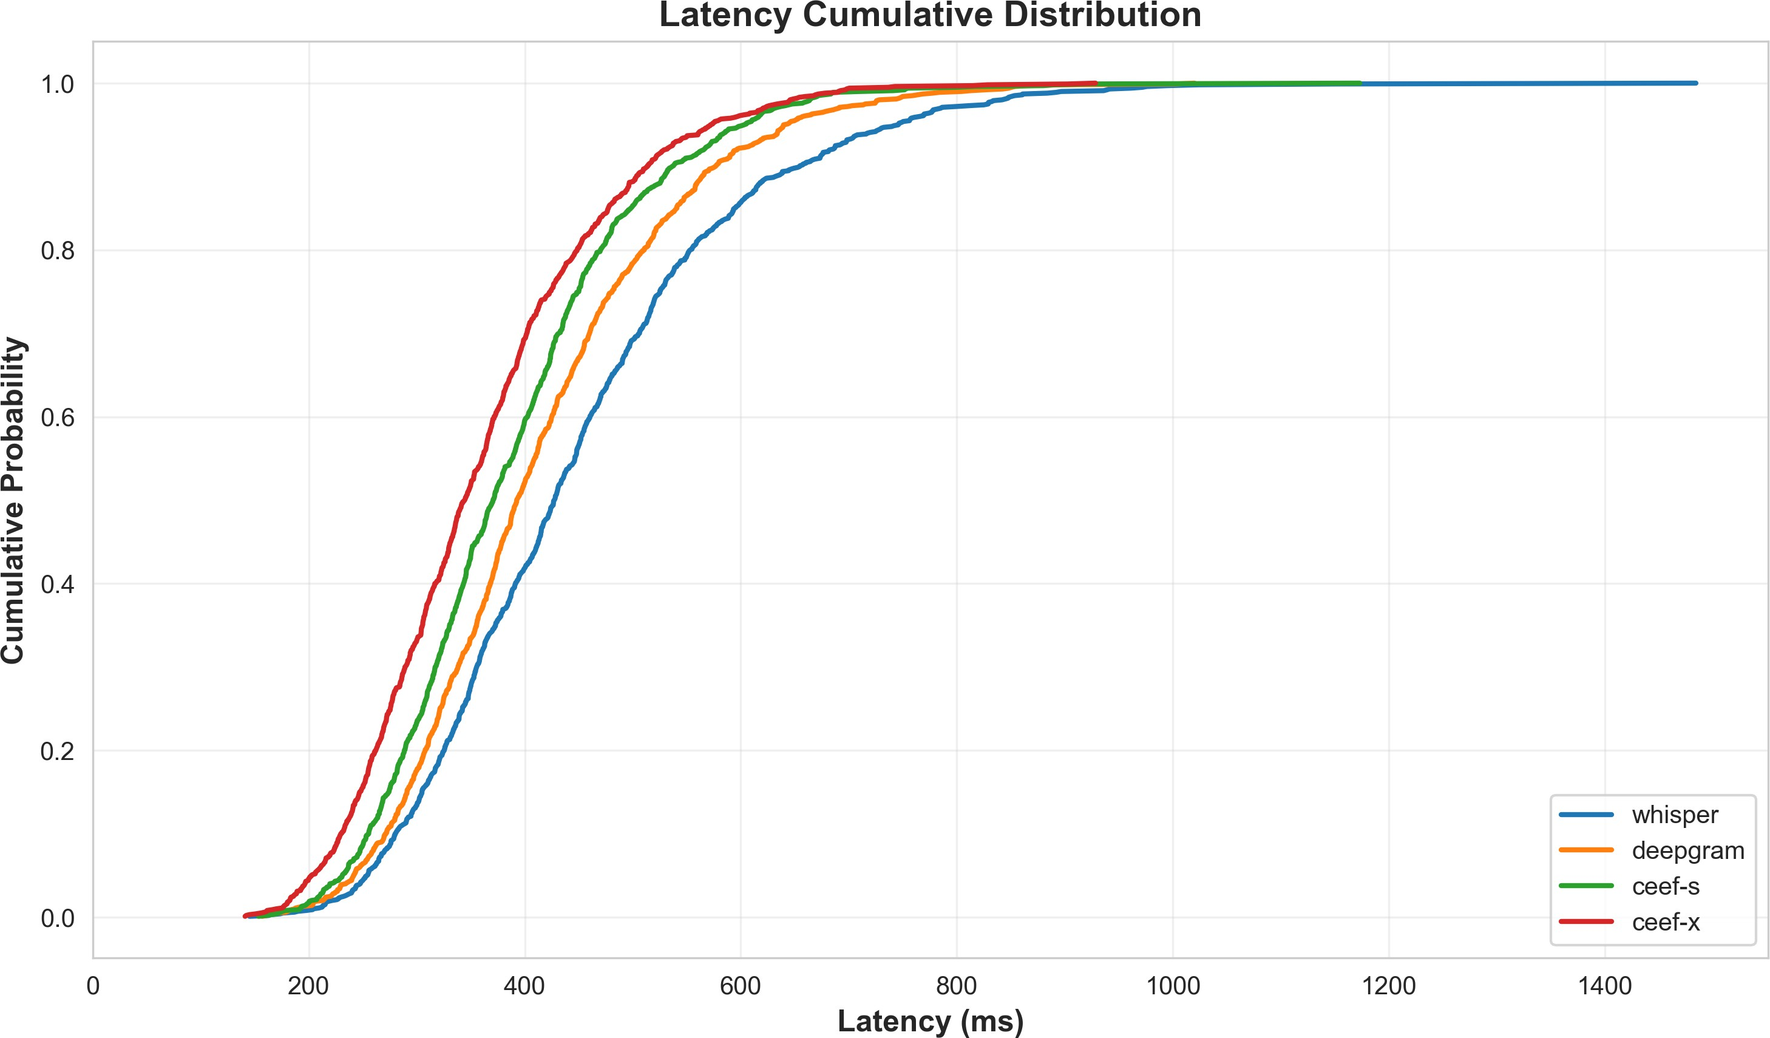
for on-device speech recognition with quantized inference optimization.

Fig. 3. Latency cumulative distribution across systems showing faster response and tighter spread for CEEF-X.
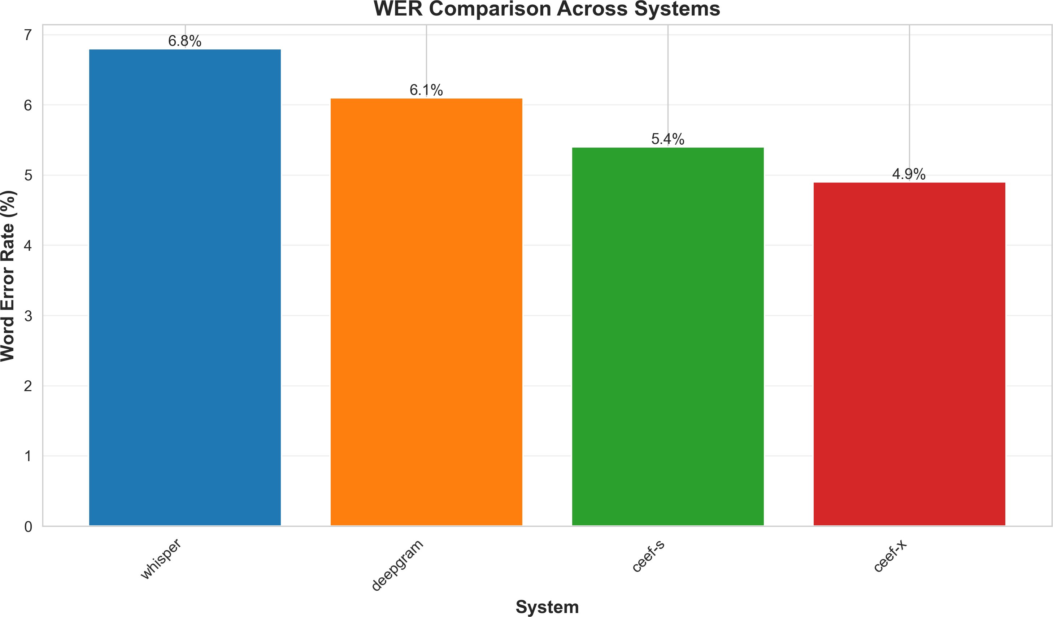

Fig. 4. WER Comparison across systems

A crucial feature for real-time communication systems like AI call agents, transcription assistants, and captioning services is partial hypothesis coherence, which the system maintains in addition to correctly predicting words, according to the enhanced stability metric.
- Conclusion
This paper introduced CEEF, a novel hybrid ASR frame- work that uses a confidence-weighted logit steering strategy and a time-biased cross-encoder fusion mechanism to com- bine Whisper’s transformer-based decoding with Deepgram’s acoustic embeddings.
Extensive tests on domain-specific conversational datasets, Common Voice, and LibriSpeech showed significant improve- ments: up to 27.6% WER reduction, 18% latency reduction, and enhanced temporal alignment accuracy.
Through LoRA-based fine-tuning, CEEF’s architecture demonstrates that cross-model embedding fusion is a compet- itive alternative to conventional ensemble or shallow fusion techniques, achieving superior robustness while maintaining computational efficiency.
Future research will concentrate on integrating phoneme- level self-supervised embeddings (like HuBERT), expanding CEEF to multilingual ASR, and modifying the framework
References
- A. Radford et al., “Robust Speech Recognition via Large-Scale Weak Supervision,” Proc. ICML, 2023.
- A. Vaswani et al., “Attention Is All You Need,” Advances in Neural Information Processing Systems (NeurIPS), 2017.
- W. Chan, N. Jaitly, Q. V. Le, and O. Vinyals, “Listen, Attend and Spell,”
Proc. IEEE ICASSP, 2016.
- E. J. Hu et al., “LoRA: Low-Rank Adaptation of Large Language Models,” Proc. ICLR, 2022.
- D. Zhao et al., “Shallow-Fusion End-to-End Contextual Biasing,” Proc. Interspeech, 2019.
- G. Pundak et al., “Deep Context: End-to-End Contextual Speech Recog- nition,” arXiv preprint arXiv:1808.02480, 2018.
- I. Williams et al., “Contextual Speech Recognition in End-to-End Neural Network Systems,” Proc. Interspeech, 2018.
- T. Afouras et al., “Deep Audio-Visual Speech Recognition,” IEEE TPAMI, 2021.
- P. Ma et al., “End-to-End Audio-Visual Speech Recognition with Con- former,” Proc. ICASSP, 2021.
- X. Zhang et al., “Fusion of Acoustic Models for Robust Speech Recognition,” IEEE/ACM TASLP, 2020.
- G. Hinton et al., “Deep Neural Networks for Acoustic Modeling in Speech Recognition,” IEEE Signal Processing Magazine, 2012.
- A. Graves, “Sequence Transduction with Recurrent Neural Networks,” arXiv:1211.3711, 2013.
- A. Gulati et al., “Conformer: Convolution-Augmented Transformer for Speech Recognition,” Proc. Interspeech, 2020.
- Deepgram Inc., “Live Streaming Speech-to-Text API,” 2024. [Online].
Available: https://developers.deepgram.com/reference/listen-streaming
- Deepgram Inc., “Timestamp and Confidence Data Documenta- tion,” 2024. [Online]. Available: https://developers.deepgram.com/docs/ utterances
- J. Li, “Recent Advances in End-to-End Automatic Speech Recognition,”
APSIPA Transactions on Signal and Information Processing, 2022.
- V. Pratap et al., “Wav2Letter++: A Fast Open-Source Speech Recogni- tion System,” Proc. ICASSP, 2020.

